**SOFTWARE ENGINEERING GROUP PROJECT**

**ERROR404 - CLUB EVENTS**

Team Members : Amoga, Manu and Kushal

**Update of user stories and UI**

User Story 1: As a student, I want to see the time,location, and date of the event, so that I can free up my schedule for that event.

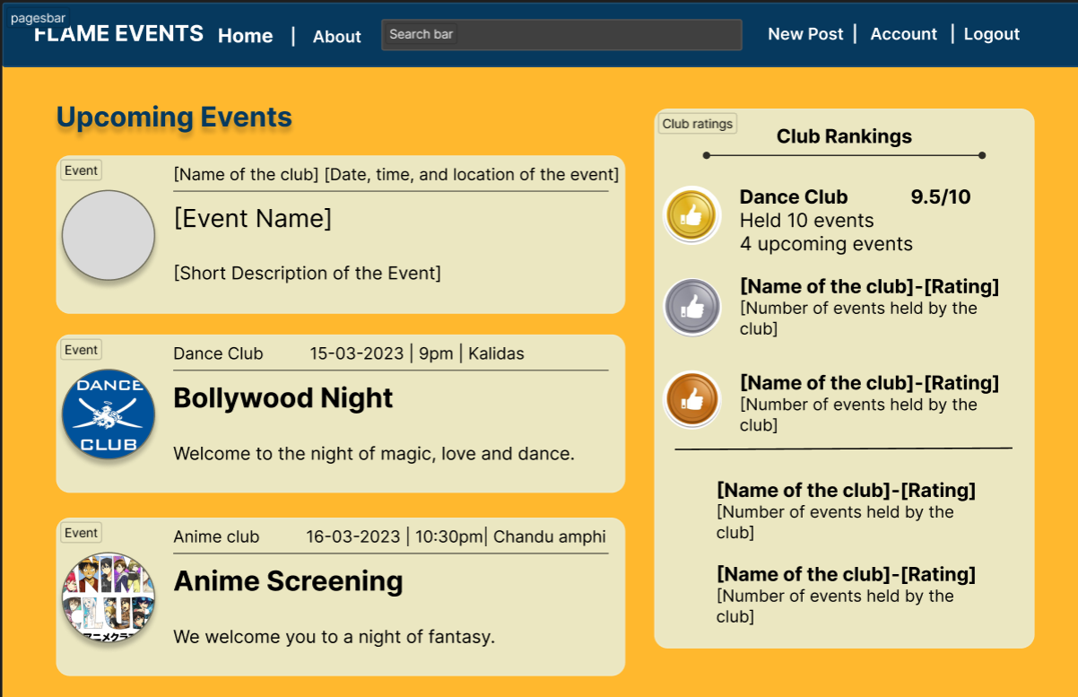

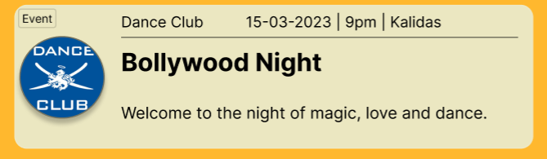

You can view the date, location, and time of each event in the home page.

User Story 2:As a student, I want a feedback page for each event, so that I can review and rate that event.



From the home page we move to the events page by clicking on the desired event.

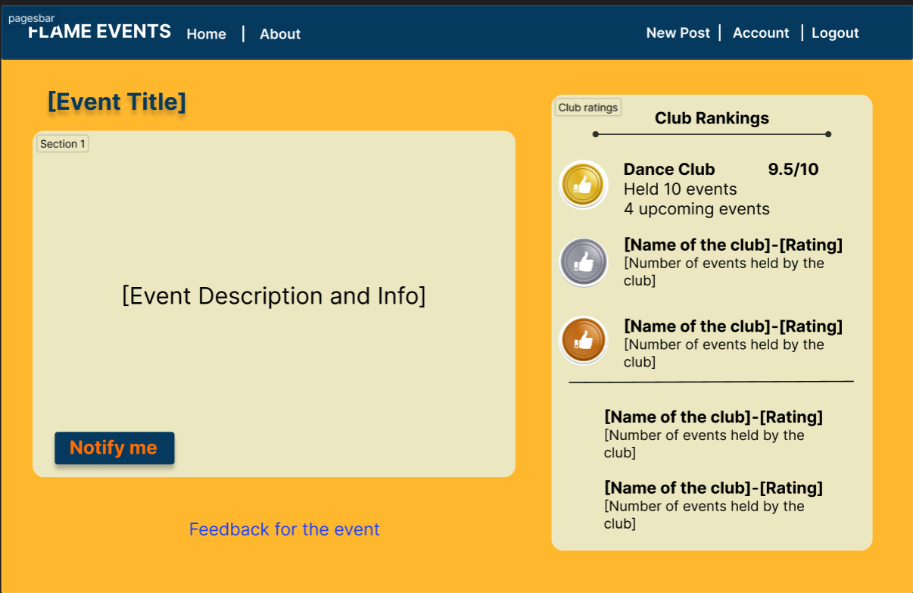

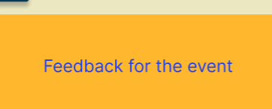

You can proceed to the feedback page from the event page by clicking on this.

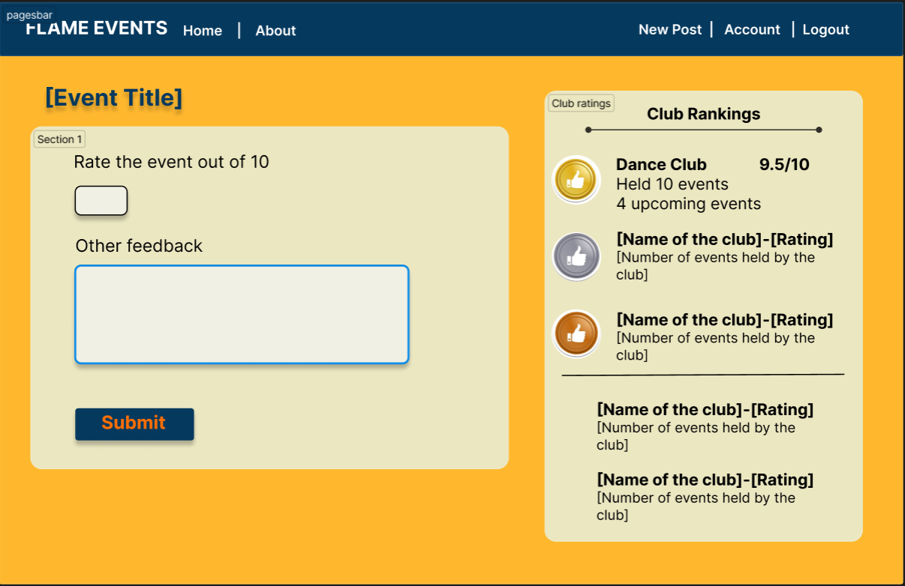

User Story 3:As a student, I want to have a notification feature, so that I don’t forget about the event happening and get reminded.



You can move from the home page to the event page by clicking on the desired event.





You can click on the notify me button in the event page to get notifications about the event.